SIT 218/738: Secure coding

**Pass task 1.2P: Dataflow diagram**

**Overview**

Your task is to draw a dataflow diagram for the following web application.

Application Description:

The web application is portal for performing static code analysis of software. The users of the application are software developers (who want to analyse their code), their managers, and administrators (of the web application). The users are authenticated using a cloud based active directory server which manages their identities. The software developers can upload their code to the webserver and perform a static code analysis (which is run in the application server) on the portal, view the analysis reports (scan results stored in the database) and prioritise the vulnerabilities to be addressed and resolve the fixed vulnerabilities (stored in the database). The software developers can also use their own IDEs to interact with code analyser via the web services API and perform the static code analysis. Their managers can view the vulnerabilities reported by the scan tool, view the progress made by the development team in fixing the vulnerabilities. The administrators can manage the whole web application.

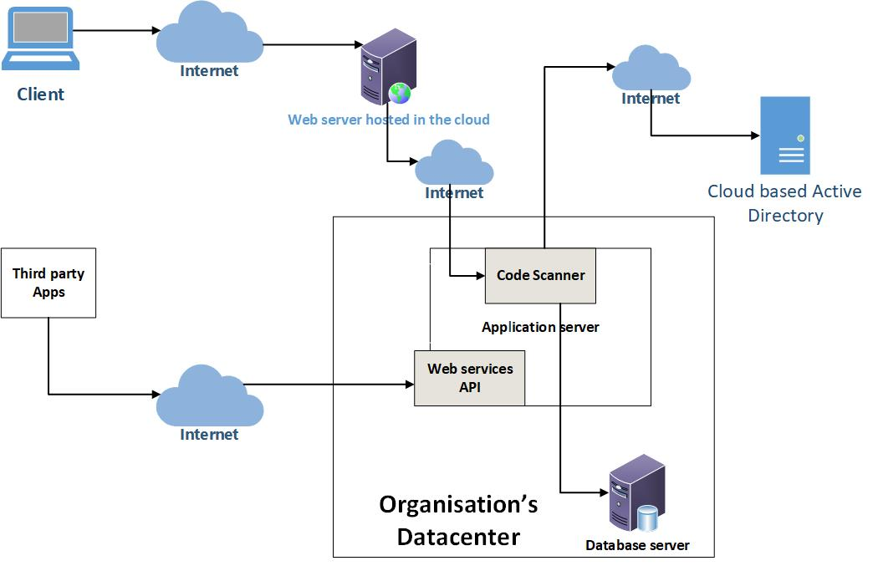

Consider a sample transaction scenario and draw a simple DFD diagram which includes:

* Highlighted entry Points
* Trust boundaries points

**Submission Requirements:**

Submit one PDF file containing DFD and with highlighted trust boundaries and entry points.